3. Procedure
In this second-order control system, our first task was to observe and interpret the resulting wave signal from the circuit. Our second goal was analysing the frequency domain and illustrating this result on a bode plot diagram as well as calculating the zeta value, this diagram can be seen in Graphs 4.1 and 4.2. The third task was to simulate the circuit using LT spice then observe and analyze the zeta value.
Task 1:
The goal of this task is to observe and interpret the oscilloscope readings for the input and output signals
Steps
- We built the circuit according to the circuit diagram in figure 2.3.1 using the necessary components.
- Then we set the input signal from the wave generator as a square wave and the experiment let the oscilloscope run and adjust the setting on the oscilloscope using DC coupling till both waves are synced and properly visible.
- Then we stopped the running waveform by pressing the ‘Run/Stop’ button on the top right-hand corner for easy readings. Here we used cursors to identify the peak time, max overshoot time, rise time and settling time (5%) to properly interpret the output signal
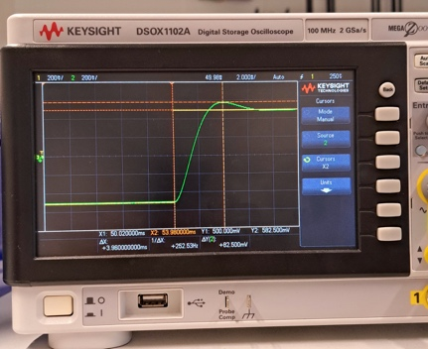
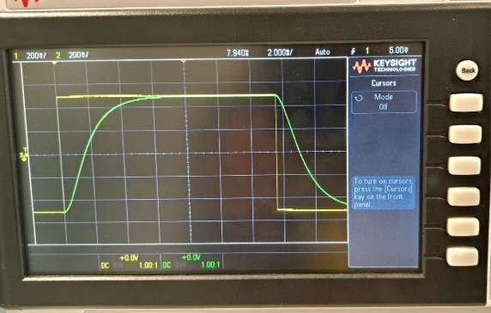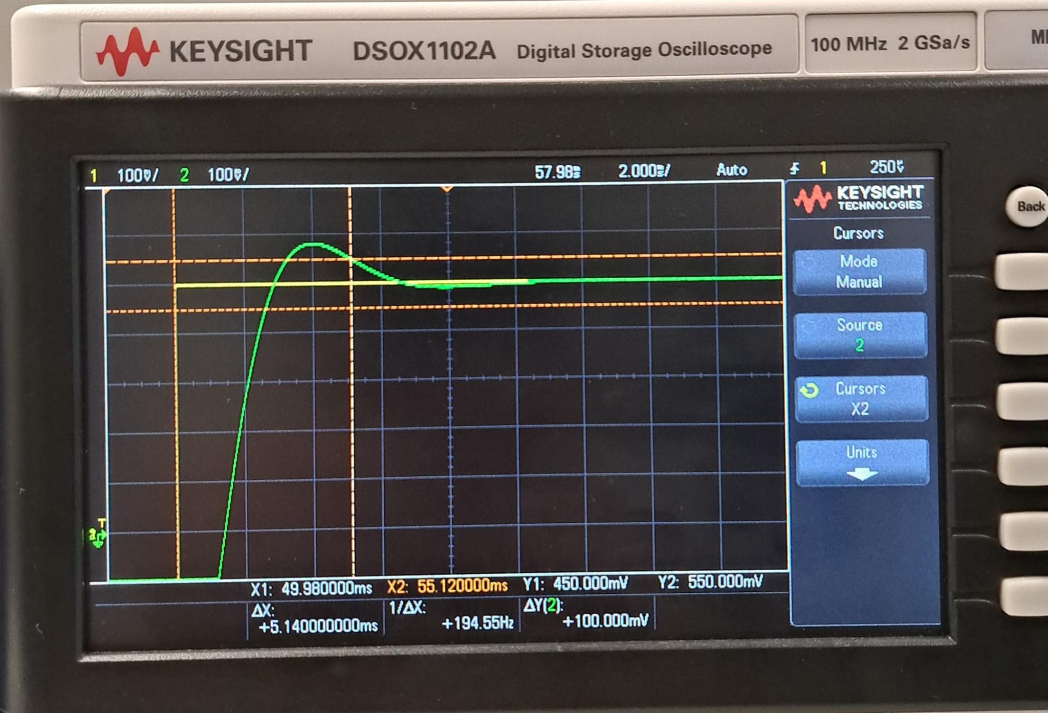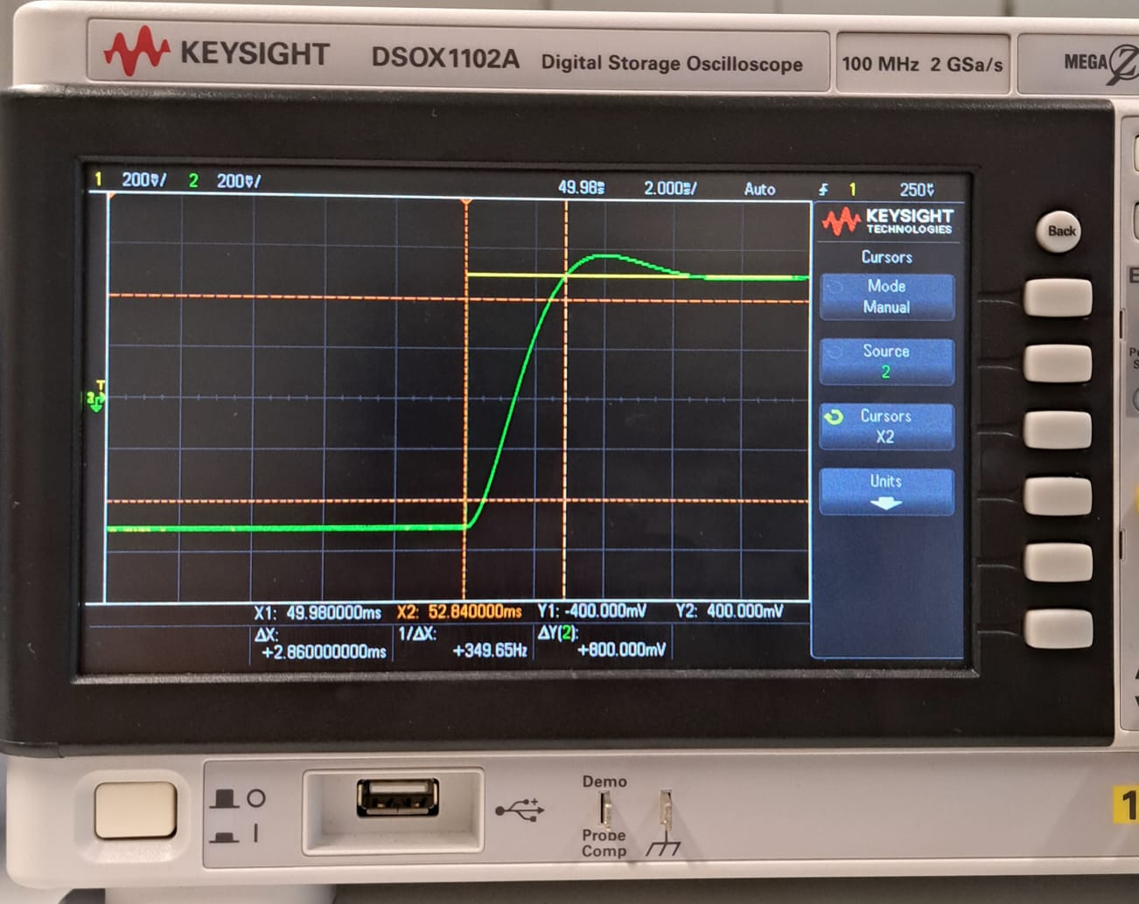
Figure 3.4: Signals with cursors set to identify peak tine and max overshoot
Figure 3.1: Synced input step and its output signals

Figure 3.2: Signals with cursors set to identify settling time (5%)

Figure 3.3: Signals with cursors set to identify rise time
Task 2:
The goal of this task is to analyse the frequency domain and use it to draw the bode plot graph using the same circuit setup from the previous task.
Steps
- Adjust the signal generator to output a sin-wave with 1V peak to peak magnitude and reconfigure the oscilloscope again to show two waves visible on the screen.
- Starting from a frequency of 1Hz, record the values of amplitude and phase shift with relevant units. Subsequent frequencies were used by multiplying the previous frequency by a factor of 1.5. For example:
1Hz
1Hz × 1.5 = 1.5Hz
1.5Hz × 1.5 =2.25Hz
- We then altered the frequency every time and adjusted the scale of the wave form on the oscilloscope to see both waveforms clearly.
- The oscilloscope's stop function freezes the signal and locked the waveform in place so both signals appeared stationary on the screen. For measurements, four cursors were used where two cursor was placed on the input signal and the other two on the output signal. The x₁ and x₂ cursors were set to measure the position where a new wave cycle starts for the input wave and the output wave respectively. And y₁ and y₂ were used to measure the amplitudes of both the waves in the order of the x cursors. The change in x₁ and x₂ (∆x) is the phase shift required to do the bode plot.
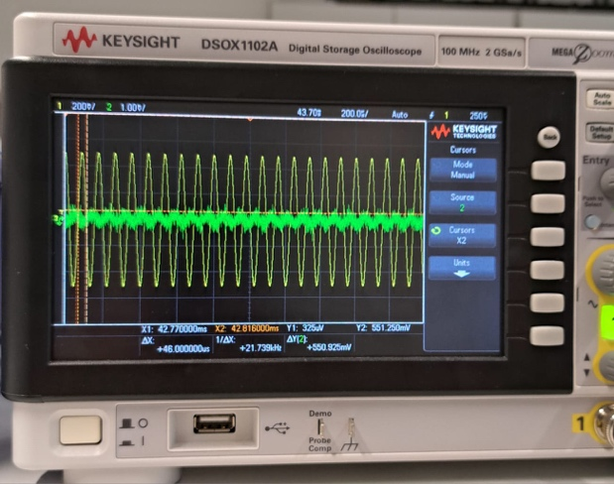
Figure 3.5: Signals with x and y cursors set to identify phase shift and Amplitude respectively

Task 3:
The goal of this task is to use LT spice simulation software to simulate the circuit then compare the output signals with the results from the experiment.
Steps
- Build the circuit design on the LT spice canvas
- Input the resistor and capacitor values according to the circuit diagram including grounding points
- Initialize the voltage source as “PULSE(0 1 0 1n 1n 5 10)” for transient analysis and “SINE(0 1 1k)” for A.C analysis
- Write the spice directive for the operational amplifier as “.include opamp.sub”
- For transient analysis, use a spice directive of “.tran 30m” and for A.C analysis use “.ac dec 10 1 500k”
- Run the program, and put the cursors at the nodes between the 50Ω and 47kΩ resistors and last node behind the amplifier
- The waveform is shown on the screen for further analysis.
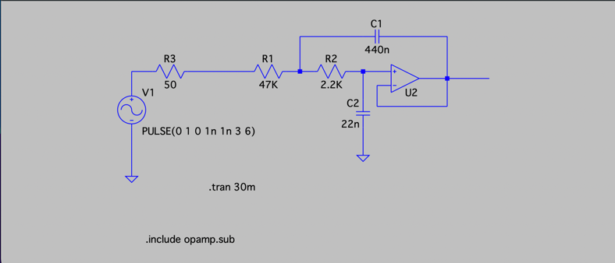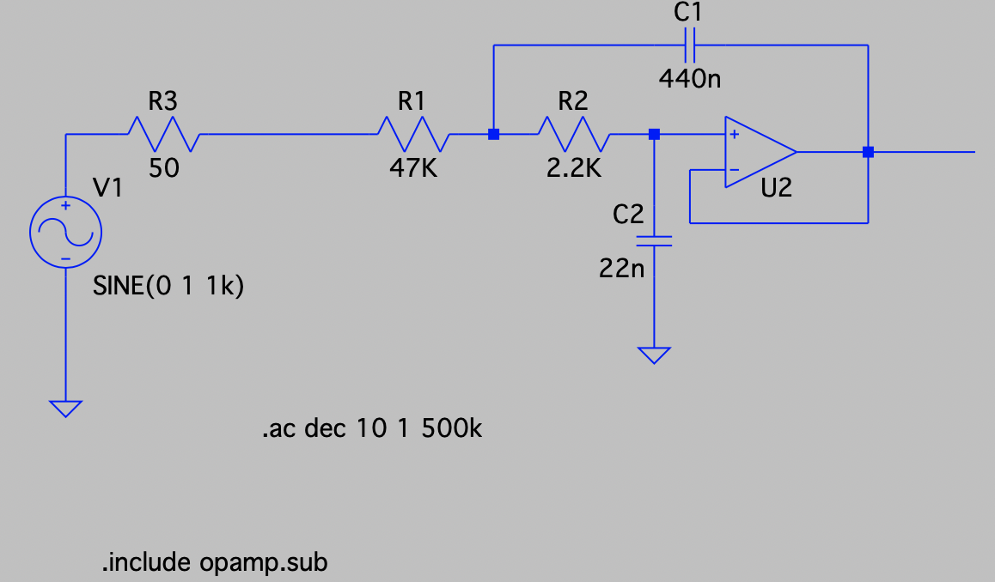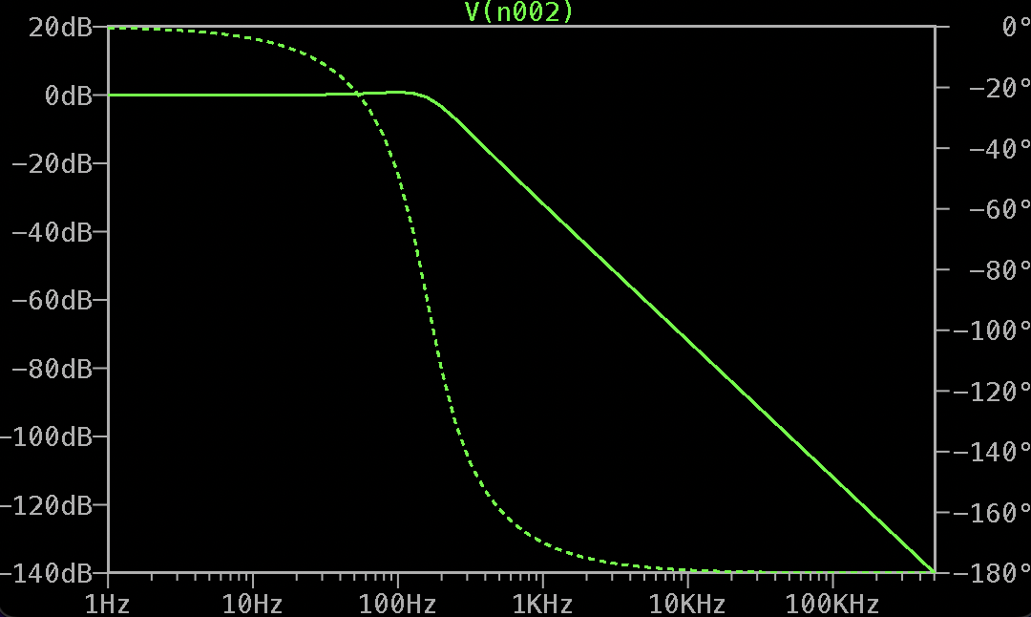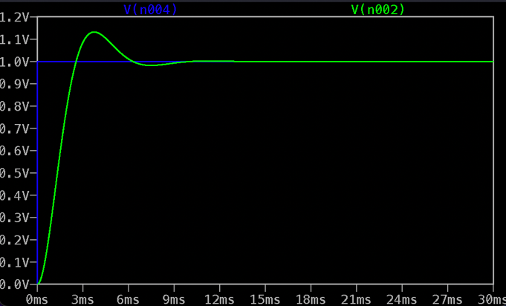
Figure 3.6: LTspice circuit for transient analysis including spice directives
Figure 3.7: LTspice circuit for A.C analysis including spice directives
Figure 3.8: LTspice waveform for transient analysis with input (blue) and output (green) signals
Figure 3.9: LTspice bode plot for A.C analysis of output signal with magnitude (dB) and phase angle (°)
From the transient analysis, the maximum overshoot (Mp) is shown as 0.134V
Using the formula, ζ = ​$\frac{-ln⁡(Mp)}{√(π^{2}+{\left(\ln\left(Mp\right)\right)}^{2})}$ the damping ratio is calculated as 0.54.

